GNFCC Members who provide Personal Protective Equipment:

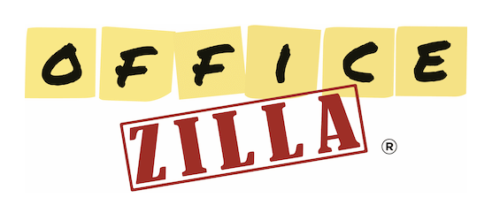
Bill Theis, 770-364-1734
https://BillTheis.OfficeZilla.com

Jim Erhardt, 214-557-0711
http://www.olivebranchservices.biz
Enter Code Jim20 for a 20% discount

Shawn LaFave, MAS, 770.710.0467
North Georgia Promotions
View Products HERE

