Application for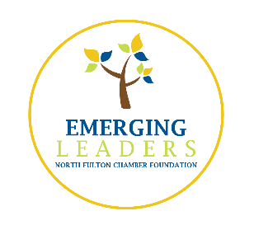 Class of 2021

Thank you for your interest in Emerging Leaders Program (ELP)!
To apply, complete the form. If possible, please submit by May 22nd.
Contact the Greater North Fulton Chamber with any questions.
www.GNFCC.com │ 770-993-8806
Confidential Application
- Tell us about yourself.
  - First Name:
  - Last Name:
  - Cell Phone:
  - E-mail:
  - Parent/Guardian Name:
  - Parent/Guardian Phone:
  - Parent/Guardian E-mail:
  - Mailing Address:
  - Favorite Quote:
  - Hobbies/Interests:
- For the 2020-2021 school year, please list:
  - Your school:
  - Grade level:
- Please list and describe your involvements or volunteerism with school, civic, and/or nonprofit organizations.
- How would you describe yourself to a new friend?
- Who encouraged you to apply to ELP?
- If accepted, what do you hope to gain from ELP?
- In a short essay below, identify one or two problematic issues confronting North Fulton students and offer possible solutions for addressing the challenge(s).
- Leadership is expressed through many skills. Identify one leadership skill you would like to develop further.
- Have you previously taken the CliftonStrengths Assessment (formerly StrengthsFinder)?
  - If yes, please list your top five Strength Themes.
- Please indicate any food allergies.

In addition to this application, it is highly recommended to submit a letter of reference from an adult who is unrelated to you. Your reference should be someone who knows you well or has worked with you in an organizational or supervisory capacity (e.g. teacher, coach, guidance counselor, pastor, etc.). E-mail reference letters to: Rachel Dangerfield at rdangerfield@gnfcc.com
Participation in ELP requires a commitment of time and energy. Candidates must be able to fulfill program requirements, including attendance at all program dates, working with a team to complete a community service project, and full payment of program fees. Participants are responsible for transportation to and from program activities.
The application period will run from January 6 through May 22nd, 2020.
2020-2021 Program Schedule:
Orientation: September 24, 2020 (6pm-8pm)
Class Day will typically run from 9:30am to 2:30pm, with a few exceptions.
Class 1: October 9, 2020
Class 2: November 3, 2020
Class 3: December 5, 2020
Class 4: January 9, 2021
Class 5: February 15, 2021
Class 6: March 12, 2021
Graduation: April 15, 2021 (6pm-8pm)
*Dates subject to change
Program cost: $250 per teen participant upon acceptance
Please save an electronic version of this and email to rdangerfield@gnfcc.com.

