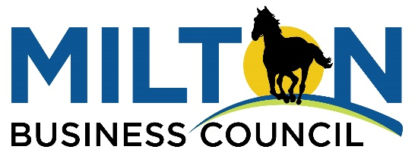

For Immediate Release:
Kali Boatright, President and CEO
Greater North Fulton Chamber of Commerce
770-993-8806

Milton Business Council to Support City Businesses
As Part of Greater North Fulton Chamber of Commerce

The Milton Business Alliance has merged with the Greater North Fulton Chamber of Commerce to create the Milton Business Council, a landmark move that members believe will provide even greater benefits to Milton’s business community.

The new Milton Business Council (MBC) will be led by Milton business leaders passionate about what’s happening now in the City and excited about the future. It will have its own identity coupled with expertise and support -- when it comes to quarterly events, professional training, and advocacy – from the Greater North Fulton Chamber of Commerce (GNFCC).

The Milton Business Alliance (MBA) had been run by volunteers since its inception in 2009. Last year, the MBA’s Board discovered that nearly half its members belonged to the GNFCC. The Board decided that uniting with the Chamber could significantly benefit the Milton business community, spurring discussions that led to this merger.

Sharon Mays, the leader of the now-former MBA, said Milton’s commercial growth in recent years had spurred her group’s board to consider “ways to better serve the expanded business community.” She and other Alliance board members believe joining with the GNFCC can do just that.

“We believe the partnership with the GNFCC and the valuable leadership it provides, will enable the Milton business community to move to the next level, offering our members more support and services,” said Mays.

Leaders of the MBA and GNFCC have been working for months to assure a smooth transition for Milton business owners.

“I am extremely excited to work with Milton business owners and Milton City leaders to form a business council that creates real value for its members,” said GNFCC President Kali Boatright. “I am also humbled that MBA leadership is willing to put their 10-year history of good work into our trust. We are committed to the success of the Milton Business Council as we move into the new decade.”

Led by Economic Development Manager Sarah LaDart, the City of Milton has worked with the local business community to create this new entity. City officials think this new organization will positively impact Milton’s business community and – by doing so – the City overall.

“We believe that the new Milton Business Council will be better equipped to serve our City’s businesses – both those now in Milton and those that come here in the future,” said Milton Mayor Joe Lockwood. “And when our businesses prosper, our entire City wins.”

The MBC will be the first organization under the GNFCC umbrella focused on a single community. The GNFCC currently represents business owners in six cities – Alpharetta, Johns Creek, Milton, Mountain Park, Roswell, and Sandy Springs. The formation of city-specific entities, like is being done with Milton, follows a model used by the Cobb Chamber of Commerce.

The MBC’s first chairman will be John Herbert from the Herbert Legal Group. Prior to assuming this role, Herbert has served as a volunteer leader with both the GNFCC and MBA.

“We are excited that the influence and resources of the GNFCC are being focused to provide robust programming and a platform to spotlight the thriving business community of Milton,” said Herbert.

For more information on the Milton Business Council, please contact the GNFCC at (770) 993-8806.

###

