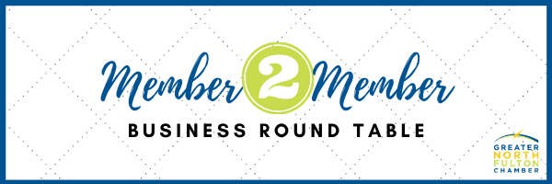

New Member 2 Member Business Round Table (M2M-BR) member groups will begin in September 2022. The objective of the Member2Member Business Round Table is to provide an opportunity to discuss business challenges, share practical business knowledge, and foster business and personal growth among the group members and in the GNFCC membership.
These groups will be designed as follows:
- Group will be a safe space for members to share, learn and grow

- 7-10-member groups with 2 co-facilitators/leaders

- 10-week commitment

- Group determines time, frequency, and location of meetings

- Format decided by group, i.e., training, goals, accomplishments, challenges, business book study, etc.

If interested in participating, either as a member or co-facilitator, please complete the below information and return it to Sophia Niemeyer at sniemeyer@gnfcc.com
YES, I would like join a group ________
Name:
Company:
Email:
Phone:
Please provide a brief description of your company, and your current role within the company. Please include size and industry:

Thank you for your interest in the M2M-BR. Please submit application to sniemeyer@gnfcc.com.
Please save the date: Kickoff meeting – September 7th at 9:30am at the chamber office

